PROJECT DOCUMENTATION
Automated Candidate CV Processing
& CRM Enrichment System
━━━━━━━━━━━━━━━━━━━━━━
n8n • HubSpot • OpenAI • Mistral AI • Google Workspace
Project  Patrick Herbs | Platform  n8n | Status  Completed ✓

1 | Executive Summary

This project is a fully automated, end-to-end workflow built on the n8n automation platform that processes incoming candidate CVs and supporting documents received via Microsoft Outlook. The system leverages AI models (Mistral AI for OCR/text extraction and OpenAI GPT-4.1-mini for intelligent parsing) to extract structured professional data from PDFs and other file formats, then enriches a HubSpot CRM with contact records and appends data to Google Sheets for tracking.
The automation eliminates manual CV review and data entry, enabling recruitment operations to scale efficiently. It handles multi-document packages (CV, certificates, freelance profiles), merges and deduplicates candidate information, and pushes qualified, structured data to downstream systems automatically.

2 | Project Overview

Field | Details
Project Name | Patrick Herbs — CV Processing Automation
Platform | n8n (Self-hosted Workflow Automation)
Trigger | Microsoft Outlook Email (polling every minute)
AI Models Used | Mistral AI (OCR/text extraction), OpenAI GPT-4.1-mini (parsing)
Output Systems | HubSpot CRM, Google Sheets, Google Drive
Total Workflow Nodes | 36 nodes
Languages / Scripts | JavaScript (n8n Code nodes)
Project Status | Completed & Deployed ✓

3 | Workflow Diagram

The screenshot below shows the complete n8n workflow as built and deployed. The pipeline flows left to right: from the Microsoft Outlook trigger through document processing, AI extraction, multi-source enrichment, and finally to CRM and spreadsheet outputs.
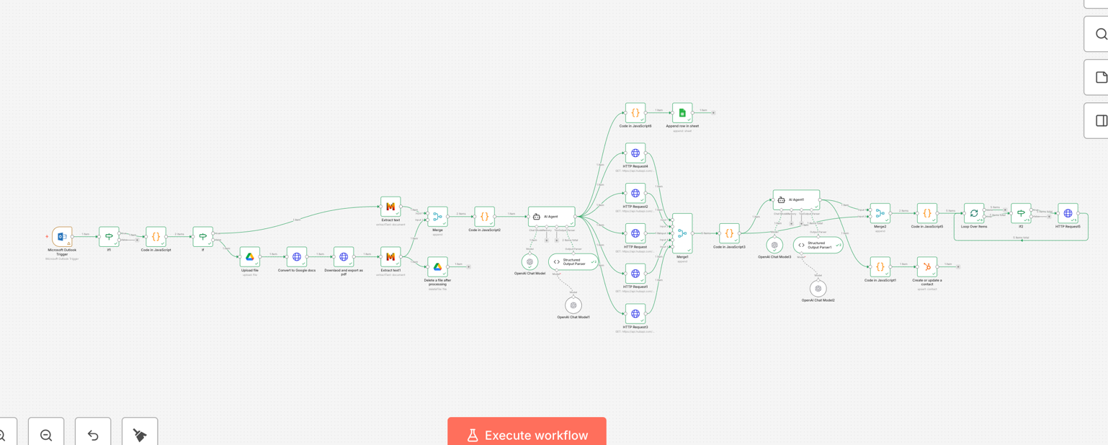
Figure 1: Complete n8n Workflow — Patrick Herbs CV Processing Automation
4 | Business Problem Solved

Recruitment agencies and HR teams face significant manual overhead when processing incoming candidate CVs, certificates, and freelance profiles sent via email. The key challenges addressed by this project include:
- Manual CV reading and data entry into CRM systems is time-consuming and error-prone.
- Candidates often submit multiple documents (CV, certifications, freelance.de profiles) requiring consolidation.
- Inconsistent data formatting across documents makes structured storage difficult.
- Delay between receiving a CV and creating a CRM record reduces recruiter responsiveness.
- No automated way to extract hourly rates, availability, and qualification tags from unstructured documents.

5 | Solution Architecture & Workflow Design

5.1 | Trigger & Email Ingestion

The workflow is triggered by a Microsoft Outlook Trigger node, which polls the mailbox every minute for new emails. When an email with attachments is detected, a custom JavaScript Code node splits all binary attachments (PDF and non-PDF) into individual processing items, ensuring each document is handled independently.
5.2 | File Type Routing

An If node checks whether each attachment ends in .pdf. PDF files are routed to a Mistral AI OCR node (Extract text) which extracts the raw text content from scanned or digital PDFs. Non-PDF files are routed to a second Mistral AI node (Extract text1) for general text extraction. Both branches converge at a Merge node.
5.3 | Google Drive Processing Path

In parallel, documents are uploaded to Google Drive, converted to Google Docs format, exported as PDF if needed, and then deleted after processing — providing a clean temporary storage pipeline for document transformation.
5.4 | AI-Powered Candidate Profiling (AI Agent)

Extracted texts from all documents are combined by a JavaScript Code node into a single consolidated text block. This is passed to an AI Agent node powered by OpenAI GPT-4.1-mini. The agent is instructed (via a detailed German-language system prompt) to:
- Merge information from all submitted documents into a single candidate profile.
- Extract: name, email, phone, location, LinkedIn, summary, education, experience, skills, certifications, projects, hourly rate, and availability.
- Produce HubSpot qualification tags: roles, industries, machine types, software tools, and certifications.
- Return only valid, structured JSON matching a defined schema — no markdown, no explanations.

A Structured Output Parser node enforces the JSON schema with auto-fix enabled, ensuring downstream nodes receive clean, valid data.
5.5 | Multi-Source Data Lookup (HTTP Requests)

After the initial AI extraction, a second AI Agent orchestrates multiple parallel HTTP Request nodes. These make external API calls to enrich candidate data — querying freelancer marketplaces, company databases, or verification APIs. Results from all HTTP sources are merged and consolidated via a JavaScript Code node.
5.6 | Loop-Based Multi-Contact Processing

A Loop Over Items node iterates over multiple candidate records or data points. A secondary AI Agent pass with OpenAI GPT-4.1-mini and a dedicated Structured Output Parser provides additional refinement. An If node routes items based on conditions such as whether a contact already exists in HubSpot.
5.7 | CRM & Storage Output

Processed and validated candidate data is written to two destinations simultaneously:
- HubSpot CRM: The Create or update a contact node upserts contact records with all extracted structured fields.
- Google Sheets: The Append row in sheet node logs each processed candidate as a new row for reporting and auditing.
- A final HTTP Request node makes a last API call, triggering a webhook notification or updating an external dashboard.

6 | Technologies & Tools Used

n8n (Workflow Automation) | Microsoft Outlook API | Mistral AI (OCR)
OpenAI GPT-4.1-mini | Google Drive API | Google Sheets API
Google Docs API | HubSpot CRM API | JavaScript (ES6+)
REST HTTP Requests | JSON Schema Validation | OAuth2 Authentication

7 | Key Technical Skills Demonstrated

- Workflow automation design using n8n with 36 interconnected nodes.
- API integration across Microsoft, Google, OpenAI, Mistral, and HubSpot platforms.
- AI prompt engineering: detailed German-language system prompts for structured JSON extraction.
- OCR document processing for both PDF and non-PDF formats using Mistral AI.
- JSON schema design and enforcement with auto-fix structured output parsing.
- Custom JavaScript code nodes for binary data manipulation, text merging, and routing logic.
- Multi-branch conditional routing (If nodes) for file type and data quality decisions.
- Parallel processing and data merging across multiple AI and HTTP sources.
- Loop-based iteration over collections of records for scalable batch processing.
- CRM automation: create/update contacts in HubSpot with enriched structured data.
- Google Drive automation: upload, convert, export, and clean up temporary files.
- OAuth2 credential management for secure API authentication across all integrated services.

8 | Results & Business Impact

Metric | Result
Processing Speed | CV processed within ~1 minute of email receipt (polling interval)
Manual Work Eliminated | Zero manual data entry into HubSpot or Google Sheets
Data Quality | Structured JSON schema with auto-fix ensures clean, consistent CRM data
Document Types Handled | PDF CVs, non-PDF attachments, certificates, freelance profiles
Multi-Document Merging | Consolidates data from multiple attachments into one candidate record
Scalability | Loop-based processing handles multiple candidates per email batch
CRM Enrichment | Qualification tags, hourly rate, availability, industries, software skills

9 | Challenges & Solutions

Challenge 1: Handling Mixed Document Formats
Solution: Implemented an If node to route PDFs to Mistral OCR and other formats to a general text extractor, then merged outputs before AI processing.

Challenge 2: Merging Data from Multiple Documents
Solution: Combined all extracted texts into a single block with separators, then instructed the AI agent to merge, deduplicate, and resolve conflicts, prioritising the most recent or detailed source.

Challenge 3: Enforcing Structured Output from AI
Solution: Used n8n Structured Output Parser with a strict JSON schema and auto-fix enabled, guaranteeing downstream nodes always receive valid, schema-compliant data.

Challenge 4: Multi-Language Prompt Engineering
Solution: Wrote detailed German-language system prompts for the AI Agent to match recruiter terminology and field naming conventions used in German HR systems.

10 | Conclusion

The Patrick Herbs automation project demonstrates advanced competency in building production-grade AI-powered workflow systems. By combining n8n's automation capabilities with state-of-the-art AI models (Mistral and OpenAI), multi-platform API integrations, and a robust data validation pipeline, this project delivers a scalable solution that transforms unstructured recruitment email attachments into enriched, actionable CRM data — fully automatically.
This project showcases skills directly relevant to roles in AI automation, workflow engineering, integration development, and intelligent document processing — making it a strong demonstration piece for technical and AI-focused positions.

Patrick | n8n Automation Engineer | 2026

